Common Core Assignment for History 232 Assessment cycle 2019-2022

Using both primary and secondary sources, evaluate the validity of a claim about US history that appeared on social media in the form of a meme during the last ten years. The claim may be explicit or implicit and must refer to the time period of this course. The bulk of your paper should be devoted to evaluating the relative value of the sources you use.
The purpose of this assignment is to advance your ability to reason through a specific historical issue and to communicate through written text your ideas. Thus: Your paper should critically consider the issue/problem and deliver all relevant information. You should also provide a clear thesis statement. In a paper this size, your introduction and thesis should appear in the first paragraph. Make sure to paraphrase your sources accurately. In other words, state what the source says, not what you wished it said or thought it said. You need to state the evidence fairly, even if you think it wrong or offensive. Your paper should use evidence to address the historical issue. Your paper should develop and organize your thoughts clearly and logically. Outlining is necessary, but not required, step in writing a well-organized paper. Your paper should draw a conclusion that addresses the paper’s chief topic or question and that states your response to the issue or your contribution to the topic.
Formatting:
Your paper needs to be typed, double spaced, 12 pt. Times New Roman font. A minimum of two full pages. You will need to cite your sources using the Chicago Manual of Style. Here is a link to an online resource for those unfamiliar with this style:
https://www.chicagomanualofstyle.org
You will need to use footnotes for in text citations and your paper needs to have a works cited page with the sources you used in your paper. You must use a minimum of five sources including the meme.

something is wrong. IT IS YOUR RESPONSIBILITY to make sure the submission went through. When the submission has been processed correctly there should be a round yellow circle with an exclamation point in it on blackboard under your grades for this assignment. If there are only dashes for your grade it means nothing has been submitted. You will upload the assignment like attaching a document to an email. After you have submitted it will ask you to wait while it checks your document. Blackboard will tell you when your submission has been accepted and has been uploaded. If you have any further questions about the submission process email or speak to your professor.
The following are examples of social media claims about history. In some cases, the claim is obvious; in others, it is implicit. (For example, the Theodore Roosevelt meme makes a claim about the nature of early twentieth-century masculinity and invites you to discuss which aspects of his career are being thus stereotyped as “male.”) You may use one of these images as the subject of your essay or find your own.
2.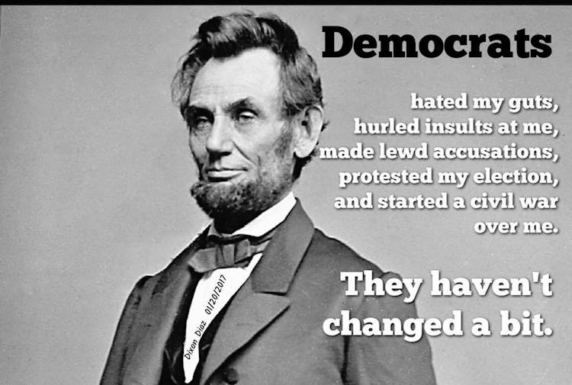 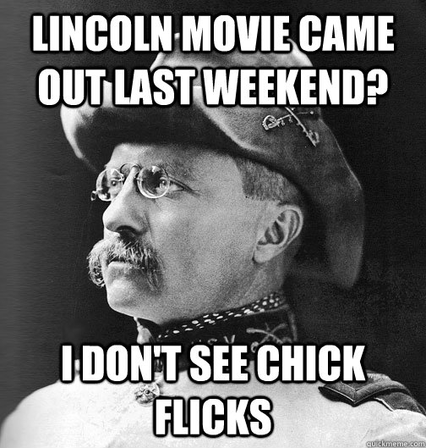

3.


